A Visual Password Recognition Application Based On the American Sign Language

¹Cory Shirts, ²Kevin Ellsworth, ³Wei Dang
Department of Electrical and Computer Engineering
Brigham Young University
Provo, Utah, 84604, USA
¹c.shirts@gmail.com, ²Kellsworth1010@gmail.com, ³weidang@et.byu.edu

Abstract – Developing sign language applications for deaf people can be very important, as many of them, being not able to speak a language, are also not able to read or write a spoken language. Ideally, a translation system would make it possible to communicate with deaf people. In this project, we attempt to create a visual application that reads American Sign Language (ASL)
Keywords – Visual authentication, American sign language recognition, marker, OpenCV
I. Introduction
This is an introduction to our project. Objective, approach, and GUI.

II. SIMILAR WORK
Give a little review of what other people have done so far. What are their approaches (algorithms, tools, speed, accuracy).
III. Opencv LIBRARY
A quick overview of what OpenCV is capable of.

IV. Procedure
In this section, we are going to describe the development procedure of our project, including the GUI, preliminary attempts and their deficiencies, and our final algorithm.
Outline the general structure of our project using, perhaps, a flow chart like in the presentation, as shown in Figure 1.

A. Platform
This project uses a common webcam (pixels?), a common laptop (speed?), C++, and OpenCV-2.1.

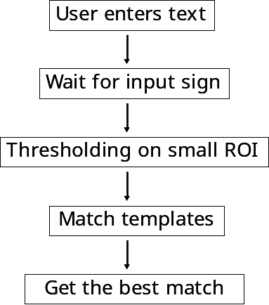

Figure 1

B. Graphic User Interface
This is the first thing we did. We have a main window capturing real time video, and three smaller windows displaying the current template, real time hand frame, and differencing image.

C. Preliminary Attempts
We started out by recognizing gestures with bare hand. Problem is.
Problem of template matching
Problem of shape matching
Glove with color markers

D. Final Algorithm
Describe our final algorithm here including template matching with saturation channel for speed up, context checking, and position distinguishing.

V. RESULTS AND Analysis
How accurate is our approach? And under what circumstance it may fail? What are the possible causes for the failures? How fast is our algorithm?

VI. Future Work
.
References
- MN00056 Protocol Manual, Rev. J, QuickSet International Inc., 2006.
- PC/104+ MSM800BEV User Manual, V1.5, Digital-Logic Inc., 2007.
- PolarRx2/2e User Manual, V2.7, Rev. 1, Septentrio Satellite Navigation Inc., 2008.

